Install instructions:

1. Download 2 files from <https://github.com/yossibu/Service-Game-Blocker/tree/master/Bin/Install>

(right click on link -> save link as..)

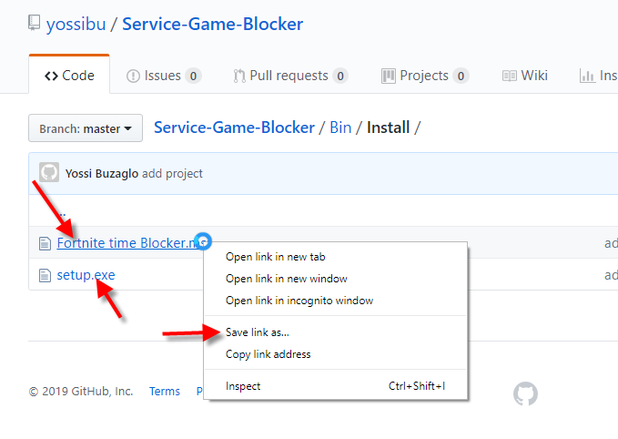

1. Double click on set.exe and click next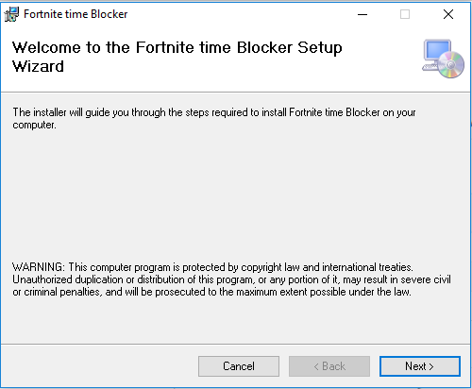

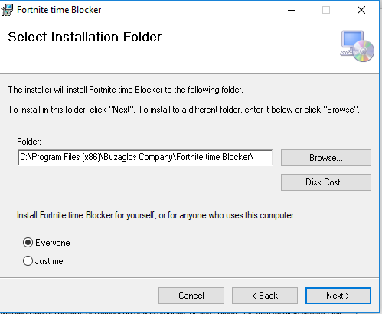

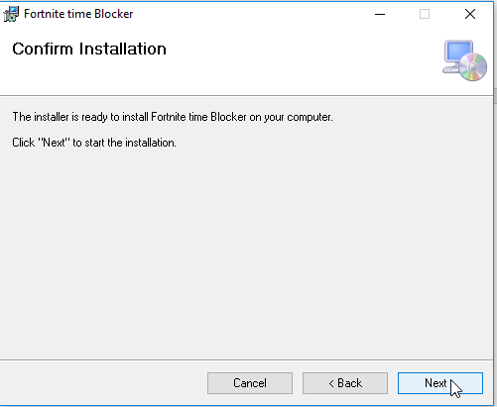

Incase User Access Control messages appear, click Yes to approve.

Install has finished, now need to configure.

Go to folder C:\Program Files (x86)\Buzaglos Company\Fortnite time Blocker\ (unless you changed it during the install)

Double click on ConfigUpdater.exe

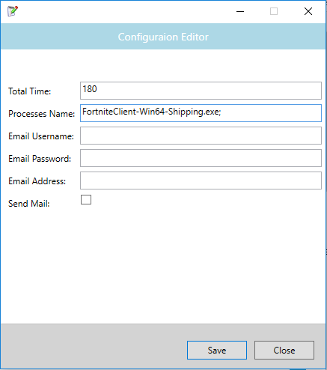

**Total Time**: in minutes, total time before message appears and game will be closed – the default value is 180 minutes -> 3 Hours.

**Processes Name**: you can define more than one process (game), the amount of time is consolidation of all processes

In caseyou want to receive mail notifications (e.g. service is stop/start)

**Note**: you need to configure your Gmail to allow third party application use your account

once finished configuration, click save.

In search area, type services and click

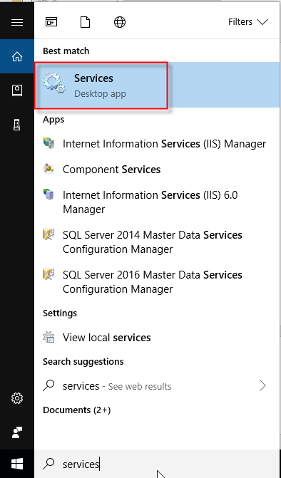

Locate the service and select it, click stop and then start

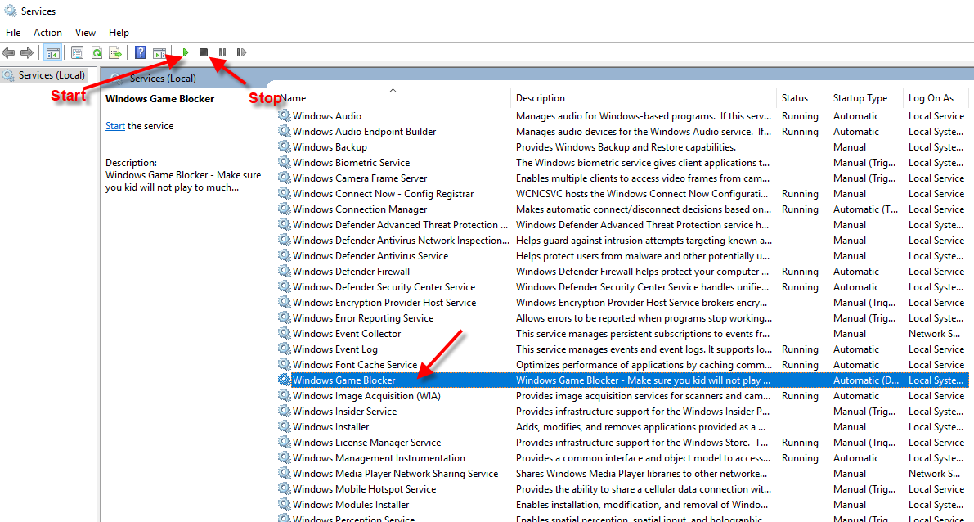

You are all set, once your kid exceeded the amount of time, he will get the below message.

